Who can pay for solar at a regional Level and which regions to work with.

Hypothesis:

To address the issue of who can pay solar and which regions to work with, a strong indication would be their access to credit, but lack access to electricity.

A Look a credit in different regions with PCA:

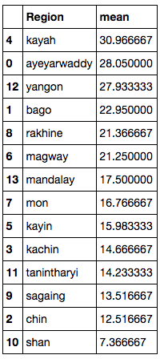

Based on their access to credit, the Kayah region has the most access to it, followed by Ayeyarwaddy, and Yangon. Using principle component analysis and a biplot, credit is broken down even further showing that certain groups’ access to credit are stronger in different regions compared to others. The directions that the vectors are pointing to have stronger credit for that type of group of people. i.e(poor, non poor, rural, urban)

The graph below show that Yangon, Kayah, Ayeyarwaddy, Bago, Rakhine, and Magway regions have the strongest access to credit for those particular groups. Not coincidently, they are also the regions with the highest access to credit overall.

The rest of the regions do not have that kind of access to credit for any group, because their vectors are not pointed to their direction.

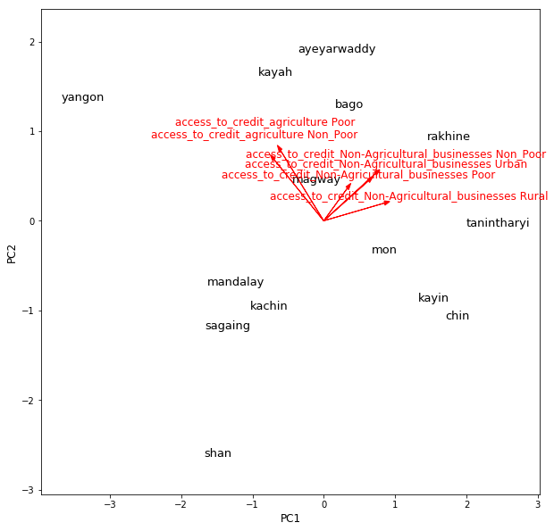

A Look at access to electricity using PCA:

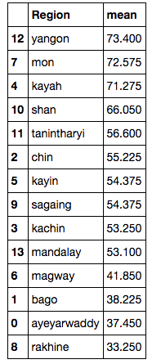By looking at the vectors, certain groups of people (rural, urban, poor, non poor) have different access of electricity based on the region they are in. Mandalay and Kayin for example, their urban areas have high access to electricity, but overall their average access to electricity is low. Yangon is in between all the vectors, which states that overall it has good access to electricity for all groups.

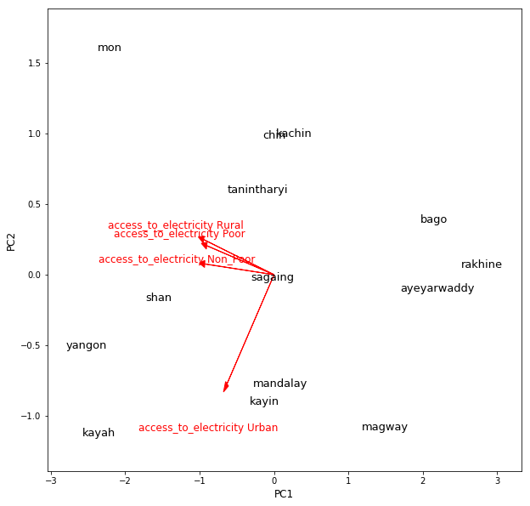

By looking closer at the vectors, certain regions with high access to credit, but do not have high access to electricity. The following regions have these traits:

Ayeyarwaddy

Bago

Magway

Mandalay

Rakhine

Potentially, these regions could be great regions to work with, because of their high access to credit and their low access for electricity.

After identifying potential places to invest on the regional level, township and village data can be used to drill down even further to see specifically which part of that region could be most valuable to invest.